**Practical 8**

**To use Ultrasonic sensor with Raspberry pi.**

**Components Required :**

* Raspberry pi
* Ultrasonic Sensor HC-SR04
* 1kohm Resistor , 2kohm Resistor
* Breadboard and wires

**\*Ultrasonic Sensor HC-SR04:**

The HC-SR04 Ultrasonic Module has 4 pins, Ground, VCC, Trig and Echo. The HC-SR04 ultrasonic range finder is very simple to use, however the signal it outputs needs to be converted from 5V to 3.3V so as not to damage our Raspberry Pi.

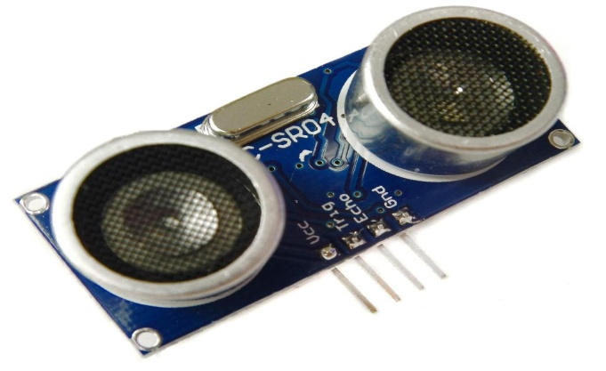

*Fig.8.1 HC-SR04*

**Steps of Connection :**

**Step1.** Plug four of your male to female jumper wires into the pins on the HC-SR04 as follows: Red; Vcc, Blue; TRIG, Yellow; ECHO and Black; GND.

**Step2.** Plug Vcc into the positive rail of your breadboard, and plug GND into your negative rail.

**Step3**. Plug GPIO 5V [Pin 2] into the positive rail, and GPIO GND [Pin 6] into the negative rail.

**Step4.** Plug TRIG into a blank rail, and plug that rail into GPIO 23 [Pin 16].

**Step5.** Plug ECHO into a blank rail, link another blank rail using R1 (1kΩ resistor)

**Step6.**  Link your R1 rail with the GND rail using R2 (2kΩ resistor). Leave a space between the two resistors.

**Step7.** Add GPIO 24 [Pin 18] to the rail with your R1 (1kΩ resistor). This GPIO pin needs to sit between R1 and R2.

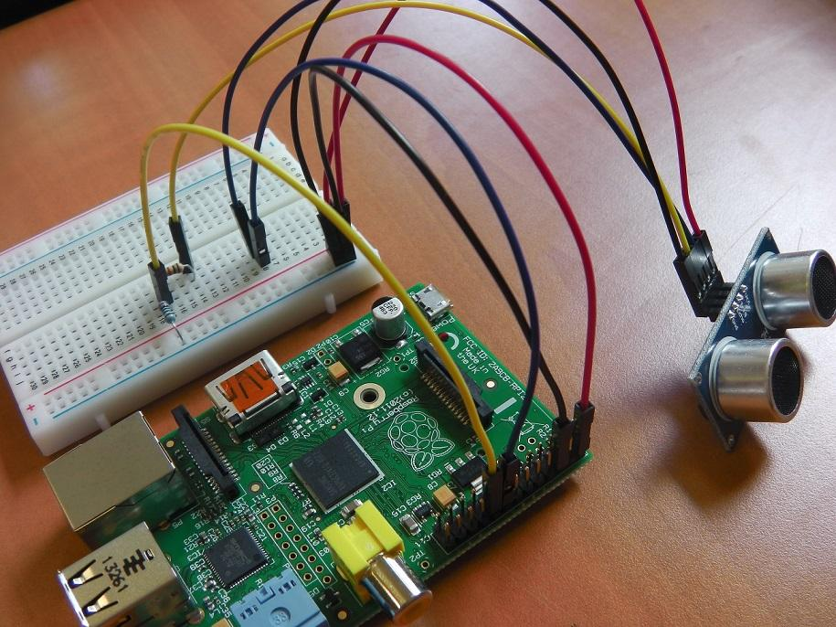

*Fig.8.2 Connections*

**Code :**

**import RPi.GPIO as GPIO**

**import time**

**GPIO.setmode(GPIO.BCM)**

**TRIG = 23**

**ECHO = 24**

**print "Distance Measurement In Progress"**

**GPIO.setup(TRIG,GPIO.OUT)**

**GPIO.setup(ECHO,GPIO.IN)**

**GPIO.output(TRIG, False)**

**print "Waiting For Sensor To Settle"**

**time.sleep(2)**

**GPIO.output(TRIG, True)**

**time.sleep(0.00001)**

**GPIO.output(TRIG, False)**

**while GPIO.input(ECHO)==0:**

**pulse_start = time.time()**

**while GPIO.input(ECHO)==1:**

**pulse_end = time.time()**

**pulse_duration = pulse_end - pulse_start**

**distance = pulse_duration x 17150**

**distance = round(distance, 2)**

**print "Distance:",distance,"cm"**

**GPIO.cleanup()**

**OutPut :**

pi@raspberrypi ~ $ sudo python range_sensor.py

Distance Measurement In Progress

Waiting For Sensor To Settle

Distance: 12.52 cm

pi@raspberrypi ~ $